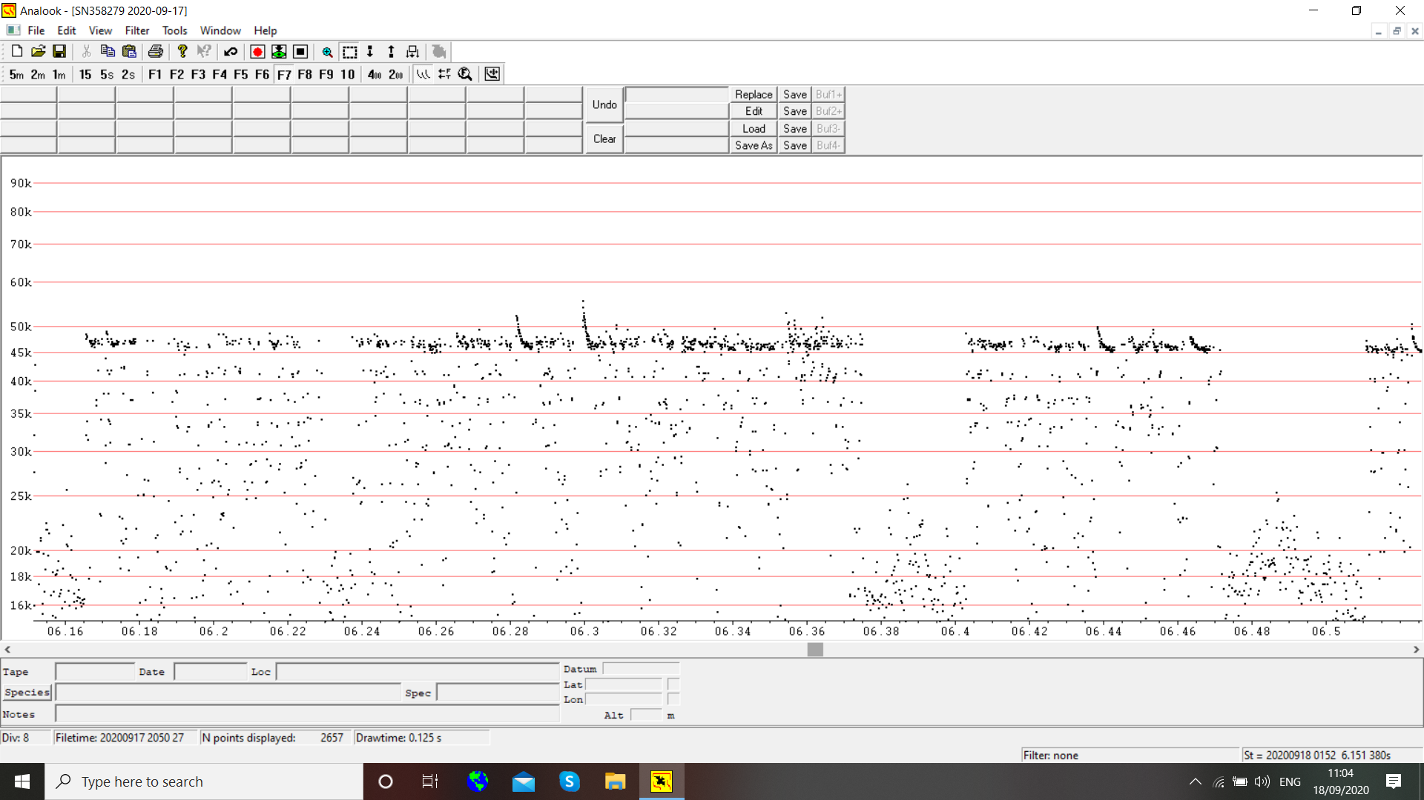
Common pipistrelle bat activity starts at 19.30 hours and continues most of the night. The peak of the activity starts at 1.00am and this screenshot is 01.52 showing constant activity
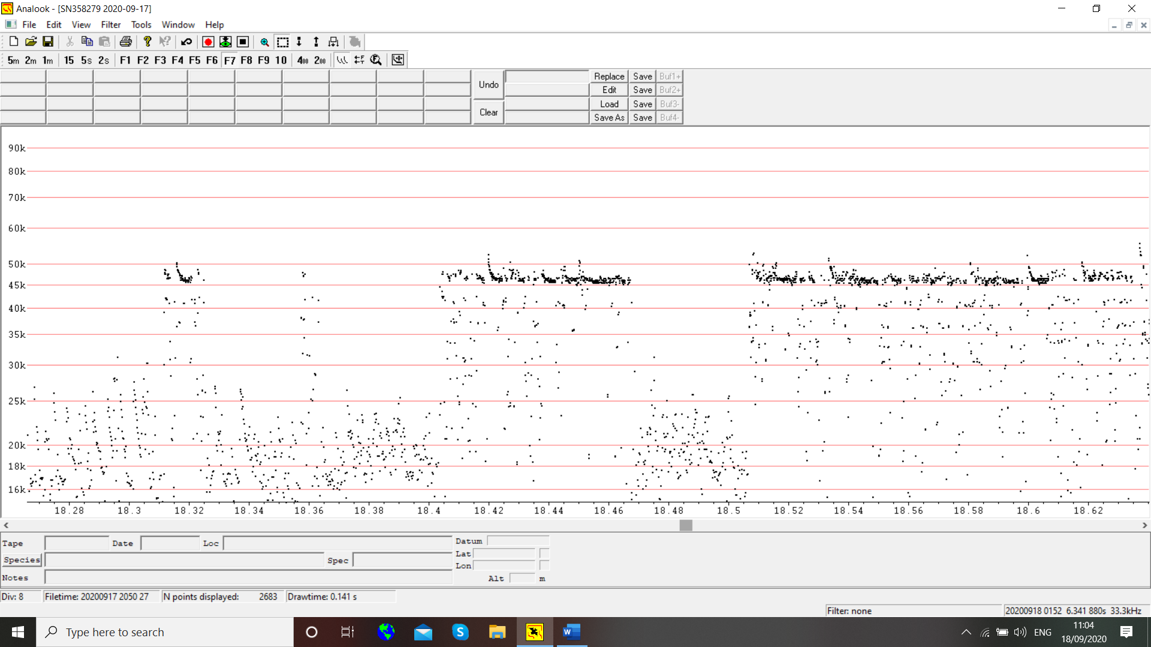
Just a short time later we get the vertical FM lines which are social calls (in 3’s). This is social activity and common this time of year. Sometimes we refer to the bat as song flighting looking for a mate.
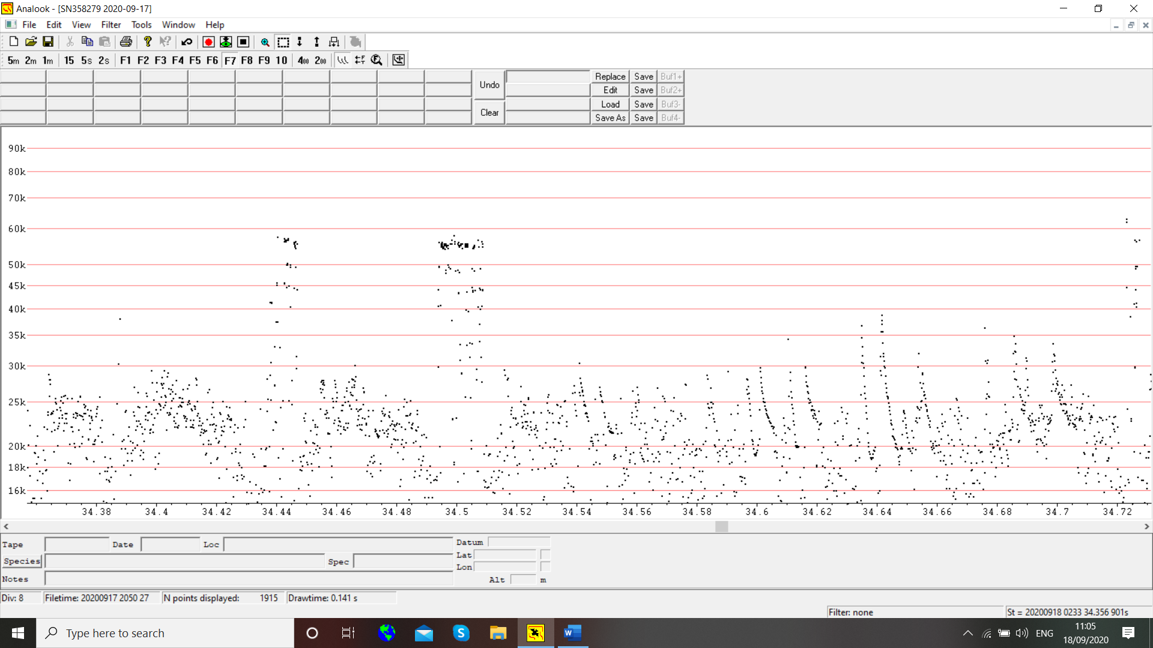
This is all FM sweeps of social calls, low frequency sound carries further than 45 kHz and so the bat is just out of range. The microphone is not well positioned.
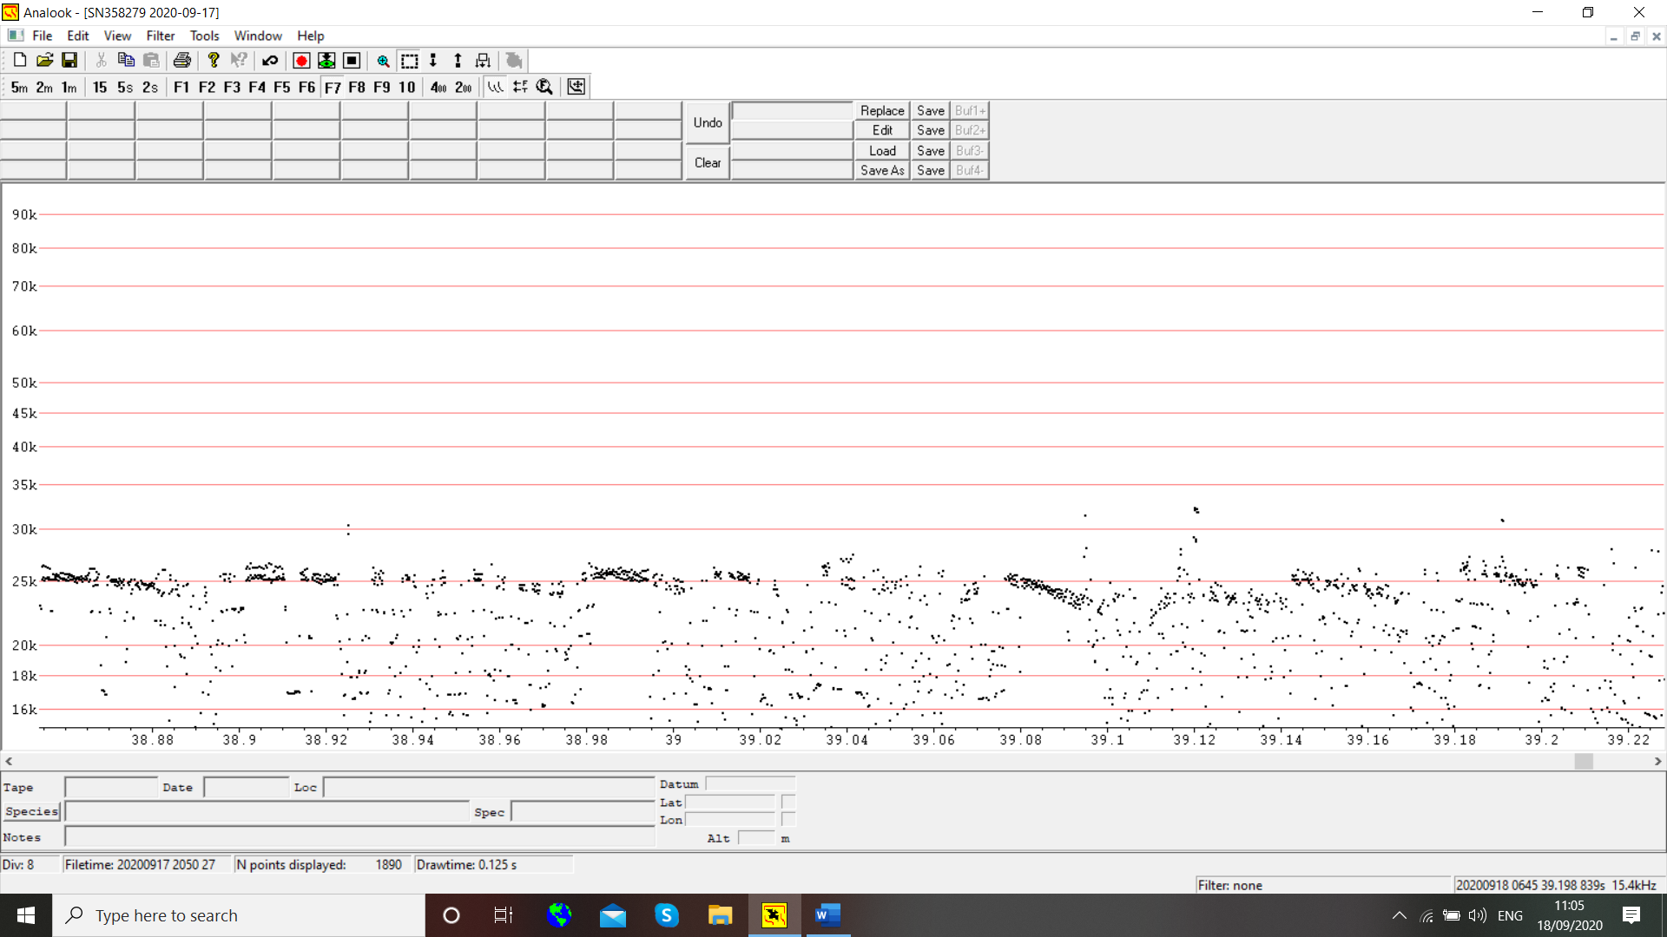
This low frequency starts at 3.30am and I think it is your equipment, it continues for the rest of the night.

I had one soprano pipistrelle in the recordings also. The first night the recordings were too faint to be interesting.

