Community Solar in Kingston
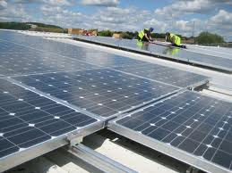
Transition Town Kingston is planning to form a community energy company (Kingston Community Energy) to install solar panels across the borough of Kingston. We are on the lookout for public and community buildings such as schools, local shops, community centres etc where we could mount solar panels and start generating renewable energy. We believe that installing renewable energy (focussing on solar photovoltaics) on the roofs of buildings will go some way to helping building owners to safeguard themselves against fluctuating energy costs and predicted price hikes in the coming years.
How does it work?
- KCE would install, own and operate solar panels on the roof of your building.
- The capital for the solar power station would be raised through a community share offer. This would be open to the general public in Kingston (and nationally) to invest in shares. Therefore the capital cost for the building owner is zero.
- Once installed the solar panels would generate power which could be used by the building (for free) during daylight. Surplus power would be fed into the grid.
- For every unit of electricity generated by solar panels a payment called the Feed in Tariff (FIT) would be made to the project. This payment is guaranteed by the government for 20 years. KCE would receive the FIT payment for the power generated.
- The income from FIT would be used by KCE to provide the capital to operate and maintain the system and then be used to pay the shareholders a small interest payment.
- Surplus income within the scheme would be invested in a community energy efficiency fund to finance home energy efficiency projects in the borough.
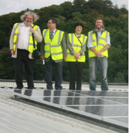
KCE is being developed by Transition Town Kingston, a voluntary community-led initiative tackling the twin challenges of climate change and shrinking supplies of cheap energy by building resilience and happiness. We are developing our project using examples of successful community owned solar projects across the country such as OVESCo in Lewes, Brixton Solar and Oxford North Community Renewables. Our team has a track record of successful solar PV projects including the recent installation on King Athelstan primary.
If you own, manage, or are in any other way involved in a suitable local community building such as a community centre, school or local shop and would like to start to generate your own renewable electricity please do get in touch so that we can explore the possibilities! Contact: kingstoncommunityenergy@gmail.com

KCE would expect to be able to generate free electricity for the building, but it will depend on the building orientation, the size of system we can install and what the government feed in tariff is at the time of installation.

